Assignment – 3

|  |  |
| --- | --- |
| Assignment Date | 01 October 2022 |
| Student Name | S Keerthana Sri |
| Team ID | PNT2022TMID53370 |
| Student Roll Number | 2127190501057 |
| Maximum Marks | 2 Mark |

**Question 1:**

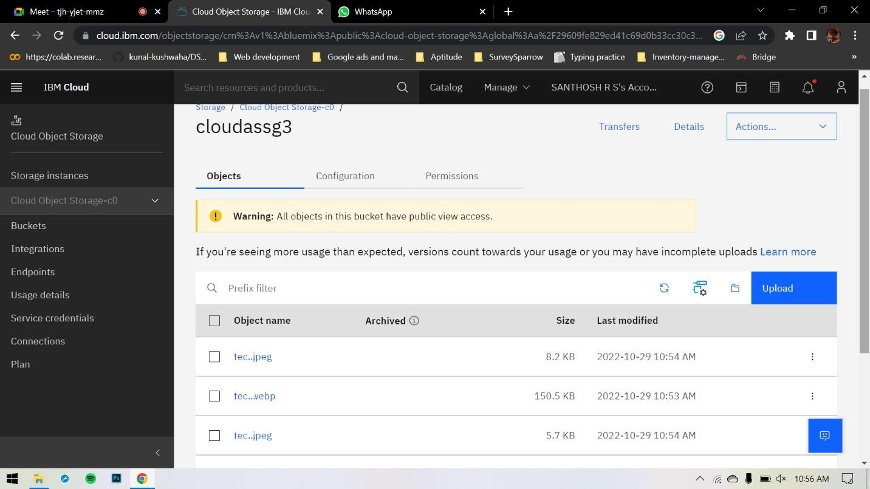**Create a Bucket in IBM object storage**

1. **Upload 5 images to IBM object storage and make it public. write html code to displaying all the 5 images:**

**Html code**

<html>

<head>

<link rel="stylesheet" href="style.css">

</head>

<body>

<img src="https://cloudassg3.s3.jp-tok.cloud-object-storage.appdomain.cloud/tech1.jpeg "alt="loading"/>

<img src="https://cloudassg3.s3.jp-tok.cloud-object-storage.appdomain.cloud/tech2.webp" alt="loading"/>

<img src="https://cloudassg3.s3.jp-tok.cloud-object-storage.appdomain.cloud/tech3.jpeg" alt="loading"/>

<img src="https://cloudassg3.s3.jp-tok.cloud-object-storage.appdomain.cloud/tech4.jpeg" alt="loading"/>

<img src="https://cloudassg3.s3.jp-tok.cloud-object-storage.appdomain.cloud/tech5.jpeg" alt="loading"/>

</body>

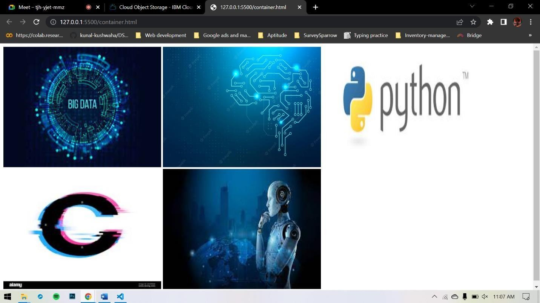</html>

# Upload a CSS style sheet to the object storage and use the same page in your HTML

img{ width:

30%; height:

50%;

}

# Design a chatbot using IBM Watson assistant for hospital. Ex: User comes with query to know the branches for that hospital in your city.

**https://web- chat.global.assistant.watson.appdomain.cloud/preview.html?backgroundImag eURL=https%3A%2F%2Fau- syd.assistant.watson.cloud.ibm.com%2Fpublic%2Fimages%2Fupx-110aad4b7d7a-4de5- aaa5-a896e6ab6e95%3A%3A3db70013-dbb5-4a6a- b146d5c96991a078&integrationID=e89449b5-86f6-4a1d-9317-**

**7c765f262d13&region=au-syd&serviceInstanceID=110aad4b-7d7a-4de5-aaa5a896e6ab6e95**

# Create Watson assistant service with 10 steps and use 3 conditions in it. Load that script in HTML page.

